Tuesday 2 / 3.5 | Wednesday 3 / 4 | Thursday 8 hr | Friday 2 / 3
Name Tags  Introductions *carpooling  Notebooks *youtube examples: example 1 exam  ple 2  Pyramid challenge  Keva builds  Cardboard Building w/ makedo  Pool noodle builds  Marble Run  Homework: print Edison pages | Balloon rockets *Straw Builds *soda straw rockets  Scratch Coding  Makey-Makey * youtube videos: video 1 video 2 Video 3  Lesson plans  Lesson plans 2  More stuff  And more  Apps to pair  How to set up makey  Makey Piano: Video Website  Alka Seltzer Rockets  Water Rockets  Zoomy Microscopes  Catapults  HoverBoards  Paper circuits  Pipe cleaner build  Survey for us.  (Optional and anonymous) | ReUseum All Day  3131 W Chinden Blvd  208-375-7507  McVey  208-484-3290  Obert  208-860-9249  Survey for us.  (Optional and anonymous) | Butane Bubble Fire  HoverBoard  Rube Goldberg  Edison Robots  3D Printing  Slime  Junk Boats  Take the Survey!!  (https://idahostem.force.com/gms/).  Survey for us.  (Optional and anonymous)

TV iStem Resources:
- TVistem.weebly.com
- Photos and resources

Tuesday Morning
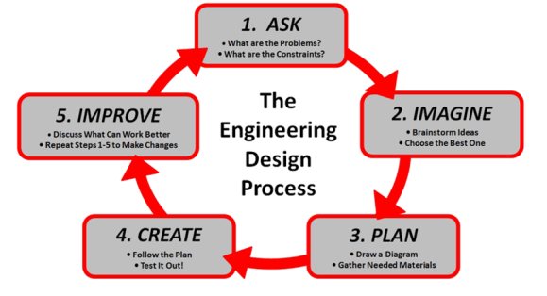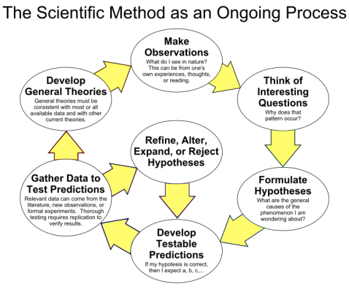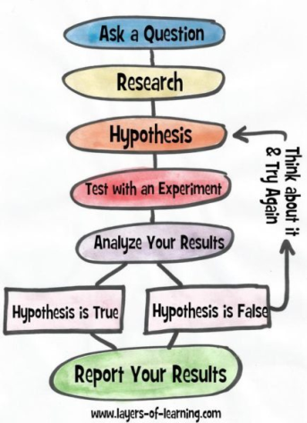

Pocket Notebooks YouTube
  - Title
  - Graphic Page - Scientific Method
  - Table of Contents
  - Each page thereafter. (Heading. and in the upper right corner page # and date)

Pyramid Challenge
  - Supplies:
    - 6 Cups
    - String
  - Build a pyramid with only the string and rubber band. Your hands may not touch the cups. Next round: Only one hand per person. Round 3: All but one person Blindfolded, one hand and use and non-dominant hand.

Keva Builds

Challenge 1:
    - How far out can you build a tower with the least amount of planks?
    - Work time
    - 1 minute to go steal others ideas and see if they are valuable
    - Consider: What is successful, what is not working for others.
    - At the end
      - Gallery Walk: Using notebooks. Record: What ideas are successful. What would you steal. (All warm feedback)
    - Curriculum ties
      - Fulcrums
      - Levers
      - Math Measurements: Measure your own and two more (Metric and standard)

Challenge 2:
    - Build the tallest tower you can that will withstand an earthquake.
      - Have students consider the base and complete a trial to start.
      - Count planks. Observe Bases. Connection to prisms (Triangles and rectangles)
      - Curriculum ties: Weather, Natural Disasters, Safety in building, Choosing where you live. (Flood plains, Hillsides sliding)

Keva Curriculum Ideas
    - KEVA Structures 200 Plank Set 34.99 (Current Price as of 6/26)
    - Off Brand (BzrkAdventures Maple Wooden Planks - Made in USA - 1000 Piece Set for 220.00)
      - We compared these to Keva. Keva is Pine - Bzrk is Maple. Equal to shape and size of Keva. Could be mixed.
    - Brainbuilders
      - Challenge Cards
    - Ozobot - Build a Maze
      - Problem Solving, Coding, Bridges, Patterns
    - Weight Challenge with Bridges.
      - Structure, design, engineering
      - Literature ties. (Build chairs for 3 little bears)
      - Weight Conversions
    - Introduce other tools. (String)
    - Harry
      - Catapults: Get Harry over the water
      - Harry in a flood
      - Harry needs steps to be rescued
      - Maze make a map using a magnet to get Harry to school
        - Tape a magnet to a car then use a second magnet to push Harry and his car to different places. (Home, Store)
        - (6 pack magnets at Lakeshore learning)
    - Marble Runs
    - Chain Reactions: Dominos
    - Ramps
      - Use different weights to see what rolls the fastest
      - Different wheels to see what rolls best

Tuesday Afternoon

- Community Grants Portal
  - For Survey on Friday

Pool Noodle Builds
  - Pool noodles (1.00 at the dollar store in the summer)
  - Toothpicks to attach noodles together
  - Cut into short pieces
    - Moleculles
    - Art projects
    - Diagram a bug
      - Stick together with toothpicks and then label the peices of the “bug”
      - Butterflies
    - Decimals and Fractions
    - Diagram Sentences.
    - Reconstruct and talk about bullying and how if you cut something it never goes back together.
    - Mad Libs. (Words on each noodle and construct meaning)
    - Dual Language connection - parts of the flower in Spanish
    - Roller Coasters
      - Purpose: Design a roller coaster for Stability, Safety, Fun Ride

Marble Run
  - Supplies
    - Pool Noodles
    - All other recyclable materials
    - Tape
  - Purpose: How long and far can you get a marble to go
- Marble runs versus Rollercoaster
  - Marble Run - Longer distance and more considerations
  - Rollercoaster - Consider slow down speed up.

Make Do
  - Supplies:
    - Make Do Tool Kits
    - Expansion Pack Short Scrus
    - XL Scru Expansion Pack
    - Cardboard and recyclable items
  - Cheaper version (But no tools)
  - What can you do:
    - Mixing materials
    - Structures
    - Bridges
    - Forgiving - you can change on the fly
    - Talk about reusing
    - Imagination
    - Have students plan and then bring in recyclables

Wednesday

Scratch Coding
  - DK Workbooks: Coding with Scratch Workbook
  - Curriculum Ties
    - Math (positive negative integers, X and Y Plane)

Makey Makey
  - Supplies:
    - Play Dough Party Packs
    - Makey Invention Kit
    - Optional Fruits. (Have students determine which work best/ conductors)
  - Piano
  - Labz (All the things)
    - Inquire about conductors
  - Makerspaces
    - Unbound, Meridian, 713 N. Main Street, Meridian , ID 83642
  - Curriculum Connections
    - Atoms
    - Conductivity
    - Math
    - Make Playdough conductive or non-conductive and test
    - Labz
  - Other Makey Makey Type Options
    - Arduino
    - RedBoard
    - Raspberry Pi
- Coding
  - Blockly
  - Tynker
  - Code.org ($$$$)

lka -Seltzer Rockets
  - Supplies:
    - Alka-Seltzer
    - Film Canister
    - Science Notebook and a table to record data
  - Curriculum Connections
    - Variables
    - Constants
    - What is happening. (On the surface)

Water Rockets

NASA Rockets Educator Guide
  - DIY Launcher
  - Water Rocket Directions
  - Aquapod - On Sale! 46.95
  - 1 Hour per day, 2 Week Project
    - Places / types to purchase
      - Delta
      - Etsy DIY Kit
      - Belleville

  - Curriculum Connection

Mini Economy resource

Zoomy Microscopes

Catapults
  - Supplies:
    - 7 Popsicle Sticks
    - 4 Rubber Bands
    - Small Lid or a spoon
  - Curriculum
    - History - What launches. What would you choose and why.

Popsicle Stick Chain Reaction
  - Cobra
  - 7 Ways to make Ninja Throwing Stars (Butterfly bomb)
  - Insane Stick Bomb
  - Curriculum
    - Patterns
    - Force in Motion

Hoverboard
  - Small table top Hoverboard supplies:
    - Balloon
    - Small water bottle cap
    - CD/DVD
  - Large Hoverboard Supplies
    - Board
    - Duct Tape
    - Bolts
    - Pool Noodles or foam insulation
  - Curriculum Connection:
    - Properties of gas
- What will you take back to your classroom
  - Alka -Seltzer Rockets
  - Popsicle sticks
  - Scratch Coding - problem solving

Pipe Cleaner Build
  - Supplies
    - 10 Pipe cleaners (or more or less) [Might want to call them craft wire]
    - Build the tallest free standing tower in 5 minutes

Thursday - Reuseum
3145 W Chinden Blvd, Garden City, Idaho 83714
websitel: educate.reuseum.org
http://educate.reuseum.org/workshops/

Steve Rodoletz: Board Member, Executive Director Direct 208-342-4776 Store 208-375-7507 email: steverodoletz@educate.reuseum.org

Glen Martin: 208-375-7507 email glen@reuseum.com

- Important Information
  - CC@educate.reuseum.org
  - Look on Instructables for CD’s and other materials how to.
  - Do you have students who don’t have computers?
    - Kids get to take it home for their use. (Low-Income and Struggling)

- Bristlebots
- Junk Drawer Robots
- Fidget Spinners
- Doorknockers

Friday

Light yourself on fire
  - Supplies
    - Butane
    - Dawn Dish soap
    - Water
    - Bucket
    - Fire Extinguisher
  - Properties of Fire
  - Properties of Gas
    - Oxygen
    - Pressure and Density
    - Gas has different properties
    - Invite the Fire Department to talk about fire safety

Hovercraft
  - Supplies
    - Heavy Plastic
    - Leaf Blower
    - Duct Tape
    - Plywood
    - Bolts
    - Coffee Can Lid
    - Foam Pipe Insulation
    - Tools to cut and put it together
    - Instructions
      - Adam Savage instructions (Don’t use the Chair)
  - Properties of Air Unit
    - Rockets
    - Airplanes
    - Hoverboard

Paper Circuits
  - Supplies
    - Battery CR2032 (Check Harbor Freight)
    - Copper Tape. Amazon Price
    - Notecard
  - Curriculum
    - Amps and Volts
    - Relays
    - Insulators
    - Poles (Positive and Negative)
    - Map of a town and light up certain buildings.
  - Snap Circuits will extend this lesson even further

Edison Robots
  - Supplies
    - Edison Robot
    - Mat
      - When printing make sure you uncheck “Fit to Page” to get it to print large size
      - Fed Ex Printing - Mat is 18
      - Print is 60
      - Check with HP Friends, Family, Student Parents for HP Printing (Free Donation)
      - Buy Mats, Laminated (Double-side)
  - Other
    - Activity Books
    - Free Lesson Plans

Slime
  - Supplies
    - Borax
    - Glue
    - Water
    - Food Coloring
  - Slime Recipes and Curriculum connections on Elmers
  - Thermomagnetic Slime
    - Heat sensitive to change colors
    - Thermochromic Pigment
  - Glow in the Dark Acrylic paint from Walmart. - Add a few drops to the mixture to make it glow in the dark

Junk Boats
  - Weighted Boats.
  - Transportation
  - Colonization
  - Mayflower

Rube Goldberg
  - OK Go Music Video
    - Failure and keep trying
    - Chain Reactions

Not Demonstrated, Good Activities for Scientific Method

- Saving Sam (or Fred) You Tube
  - Lesson Plan, Purdue University

- Dr Xargle
- Worm Observations
- Sensory Materials
  - http://parentingchaos.com/diy-kinetic-sand/

Tuber builders
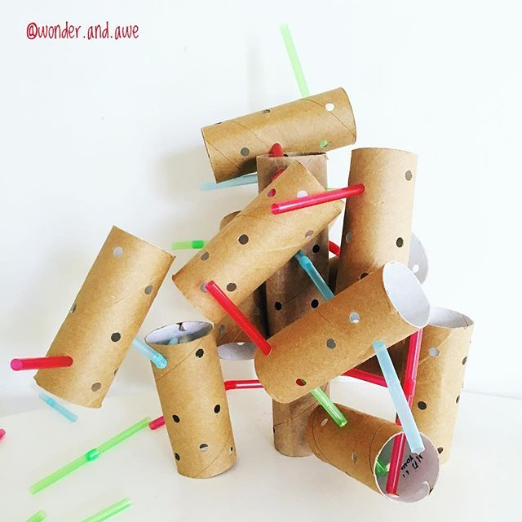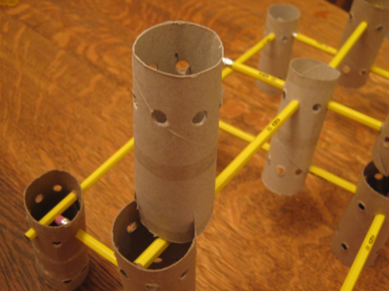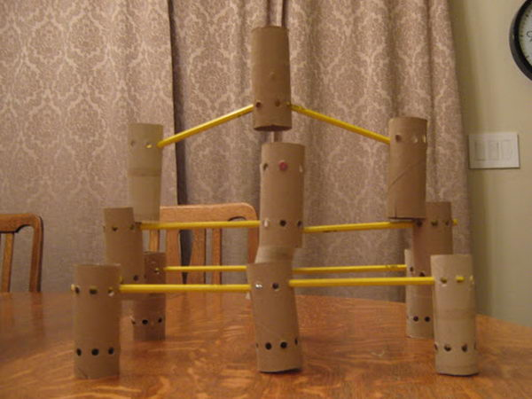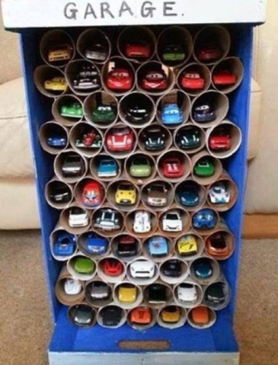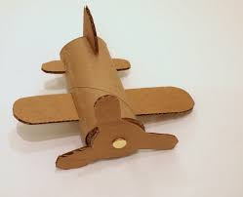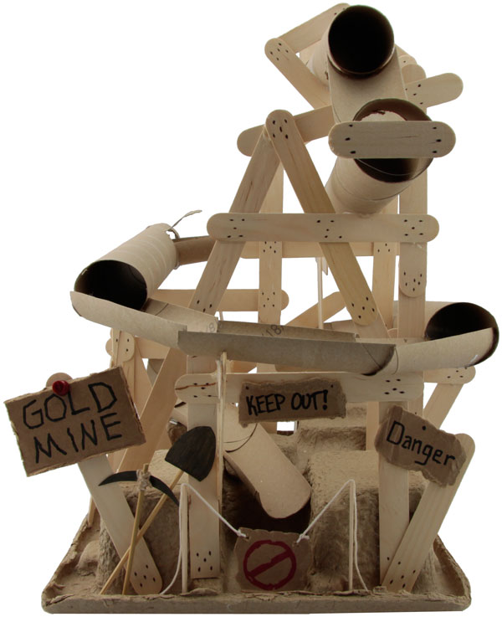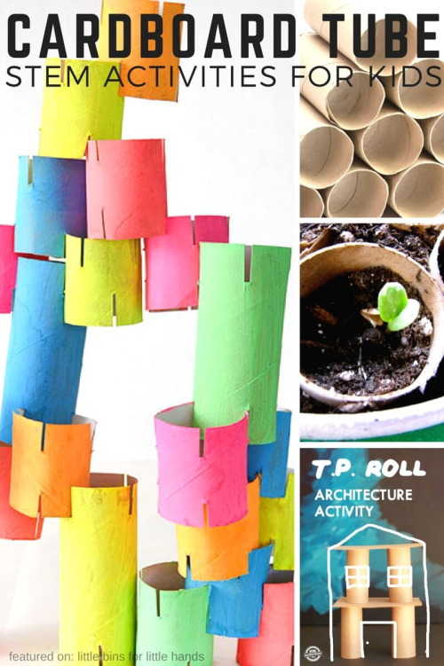

Cardboard builders
